
Name: Abdul Samad
Program: BSSE Group A
Semester: 5th
Date: October 15, 2026
*-----------------------------------------------*

Lab Task 6.1
Task 1:

Password Validation:

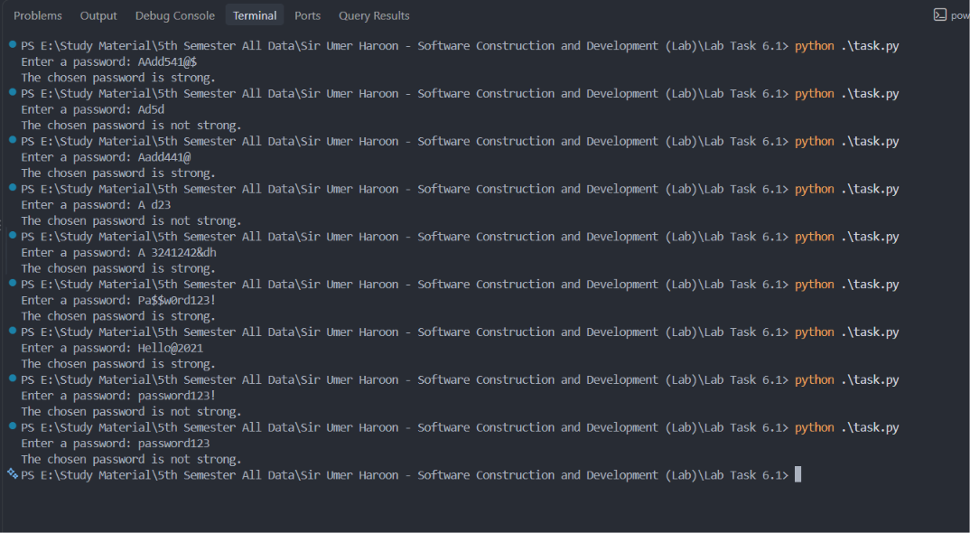

Task 2:

Post Cleaning:
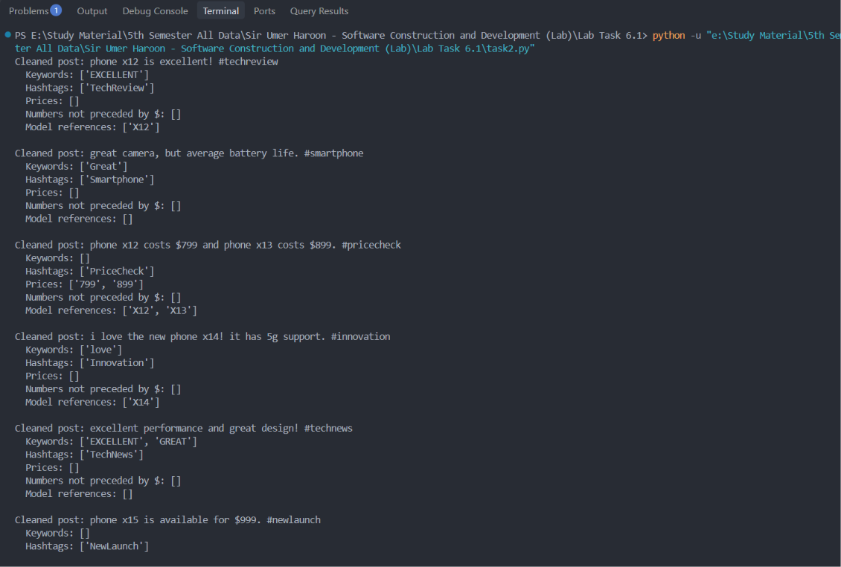
*-----------------------------------------------*

The End

